**A**

**PROJECT REPORT**

**ON**

**UAV SURVEILLANCE FOR CAMPUS SECURITY**

**PROJECT HEAD**

Dr. HENRY HEXMOOR

**COMMITTEE MEMBER**

Dr. BIDYUT GUPTA

**SUBMITTED BY**

MAHESH CHANDRA REBBA

SIU853932490



**SPRING 2017**

**DEPARTMENT OF COMPUTER SCIENCE**

**SOUTHERN ILLINOIS UNIVERSITY**

**CARBONDALE**

**ABSTRACT**

Remotely operated vehicle systems, ground and air, have great potential for supporting law enforcement operations. These systems, with their onboard sensors, can assist in collecting evidence, performing long term surveillance or in assessing hazardous situations prior to committing personnel. Unmanned air vehicles (UAVs) have three-dimensional mobility and could be used to observe wide areas. Here in the project we will see the use of unmanned air vehicles to watch over a university campus. The unmanned air vehicles move across the vast university campus and look for any harmful situations such as fire break out or any theft case. As soon as the aerial vehicles observe these kind of situations, they immediately report the location coordinates. Moreover, the aerial vehicles can keep track of a robber or burglar and update the location to the base. The police can use this information to quickly arrive at the scene and perform their duties. This project is coded in Net Logo 3D to simulate the situation and show the performance and efficiency of the aerial vehicles.

**CONTENTS**

**Abstract 2**

1. Introduction 4
2. Background 5
   1. Possible Missions 5
   2. Patrol neighborhoods 5
   3. Future of police surveillance aerial vehicles 6
3. Analysis and Design 7
   1. Initial setup 7
   2. Aerial vehicle surveillance 8
   3. Manual Control 9
   4. Identification of harmful situations 11
   5. Graphs 13
4. Implementation 14
   1. Creation of drones 14
   2. Movement of drones to pursue 15
   3. Handing the situations 16
5. Testing and Execution results 17
6. Conclusion 18

**References 19**

**1. INTRODUCTION**

Expanding threats (e.g., terrorism, weapons of mass destruction), increases in crime, and budget pressure are forcing law enforcement agencies (LEAs) to look to technological capabilities to more effectively perform their missions. The concept of having a small, very maneuverable, unmanned air vehicle (UAV) that can be operated by officers in the field to provide overhead surveillance, remote sensing, communications relay or ultimately the “fly on the wall” surveillance capability has great appeal. (Harley, 2012)

In this project, the simulation of the unmanned aerial vehicles surveying the university campus is presented. The purpose is to patrol the university campus area and provide intelligence to the campus police. Currently, the police department has a few dispatch officers. Their job is the patrol the campus during the school hours and often during the night. They maintain the security and safety of the campus. Over time, their job could become monotonous and tedious. They also serve to respond to emergency calls. Even though the campus is rather small, the average response time to an emergency call is 5-7 minutes. Because of this delay, by the time the officer gets to the location of interest, the emergency may escalate or may no longer be an issue. The timeliness of the first response may be crucial depending on the nature of the emergency. After analyzing the situation, the officer then takes the subsequent action, for example they call for backup, call the ambulance, fire brigade, or decide that the emergency is resolved and no further action is necessary. There is room for efficiency improvement in this entire process (“Evaluation and Development of Unmanned Aircraft (UAV) for DOT needs, Report No. UT-12.08”, 2012).

In this project, the unmanned aerial vehicles are developed to fly over the campus along a set of routes. The police officer, instead of having to patrol in their car, will now be able to sit in an office at the station and monitor the campus on a computer screen at a much faster pace. The GPS location will be displayed on the computer screen immediately whenever the aerial vehicles encounter a dangerous situation. During the regular flight operation, when an emergency call comes in, the drones will point towards the location of interest. The vehicle will fly a direct path to the emergency location, which will help significantly reduce the response time. During its hover operation, the vehicle will continue to transmit the location coordinates to the ground station. This will help the campus police in their initial assessment of the situation. It will help them take the appropriate action in a timely manner (McCormack, 2008).

**2. BACKGROUND**

When they are dealing with a dangerous situation, police officers are needed more information before get involved. In this way the operation of the planned intervention will be more responsible planned, more efficient and less risky. Normally this information is gathered by police on the spot. These policemen are exposed to dangers in the environment in which they operate. To avoid this situation, if conditions permit, one may use the support aircraft and helicopters. Usually, large organizations have such means but they are available in limited numbers and require qualified pilots to high operating costs. Under these conditions UAVs may be an alternative to conduct surveillance and reconnaissance activities (Neto & Paixao, 2012).

Easy to transport to the venue of the operation they can perform aerial survey of the area using a video camera. UAV enables the police to see the roof or behind buildings regardless of surface configuration. They can also be maintained for a long time over an area to help the command and control mission. (Jason, 2012b)

Operating costs are much lower compared with those of helicopters; their use is much more advantageous for the support of smaller formations of police.

**2.1 POSSIBLE MISSIONS**

UAVs may be used as a means of support, with unique potential for a wide range of 1211 missions from the police portfolio. Its ability to provide a "view from above", from multiple angles of a fixed or a moving target provides the opportunity to supply a larger amount of information that allow a more accurate analysis of an operational situation and take the most appropriate decisions to resolve. (Jason, 2012a)

**2.2 PATROL NEIGHBORHOODS**

Persistent presence of a UAV over a densely populated suburbs may reduce crime. Patrol will be most effective if they will fly both day and night, so avoiding the usual routes and flight after pre-flight programs. The observation of a target from the air at altitudes of 150 ÷ 250 m at a speed of 100 km / h, allows a 10 times greater visibility than a land patrols.

Street crime, looting, robberies, car thefts, etc. may be detected directly from the air. Based on information received may be made an intervention plan of the ground forces. Reduction in crime makes cities safer living environments for residents and gives them back their confidence in widely accepted social values (Jason, 2012a)

UAV capability to maintain for a long time over targets allows coordination of the intervention forces and warning of the dangers that threaten them. In this way reduced the risks police team members are subjected carrying out missions.

In addition to the helicopters, UAVs can fly without being detected by ground. Also there is no risk of serious injury or death to crew members, given the low-altitude flight in an area with high density of obstacles on the ground.

**2.3 FUTURE OF POLICE SURVEILLANCE AERIAL VEHICLES**

Ten times in seven years may not sound like much, but the drone revolution is just getting started (Brian, 2012).

“We are right on the tip of the iceberg,” Scott says. “Within the next five years I believe we’re going to see a saturation of drones in the United States; they’re going to be extremely common everywhere.”

“Unmanned vehicles have the potential to create new businesses and new jobs and give consumers unprecedented remote access to our skies. They also will improve and protect lives,” CEA President and CEO Gary Shapiro said at the 2015 International Consumer Electronics Show (CES) in Las Vegas.

**3. ANALYSIS AND DESIGN**

**3.1 INITIAL SETUP**

The project depicts the university campus area, environment of the campus and the aerial vehicles initially sitting at the base area. The below Fig 1 shows the pictorial representation of the initial setup of the project design.

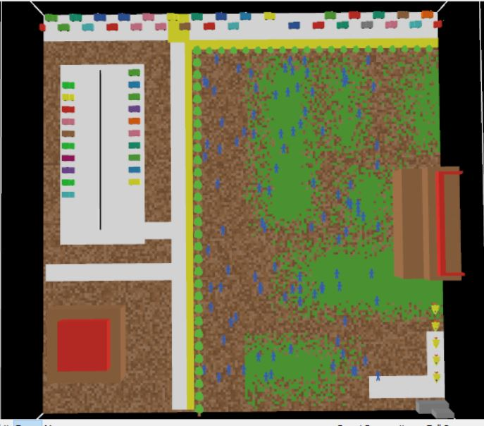

**Fig 1:** Initial setup

The below Fig 2 shows the net logo console during the initial setup.

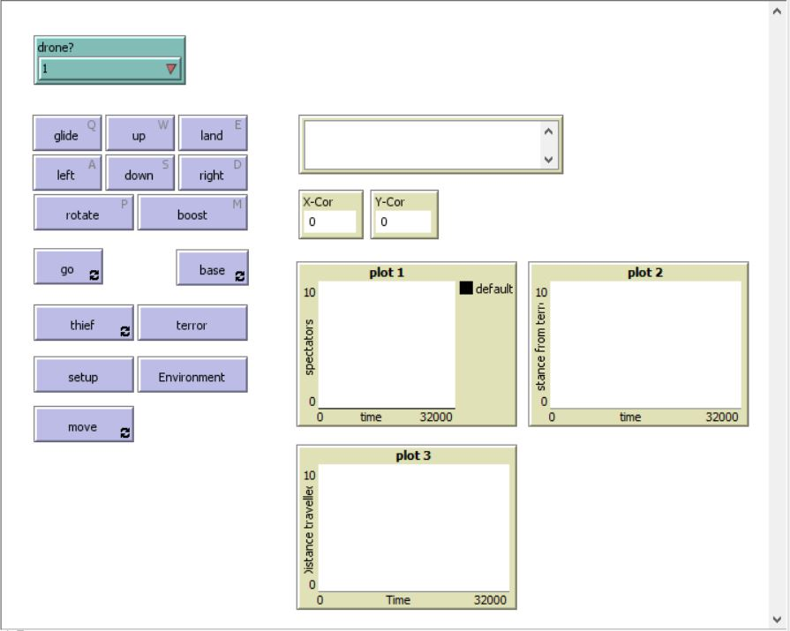

Fig 2: Net logo console during the setup

**3.2 AERIAL VEHICLE SURVEILLANCE**

In Fig 3, the aerial vehicles start surveilling the campus area moving in all possible directions covering wide range of area.

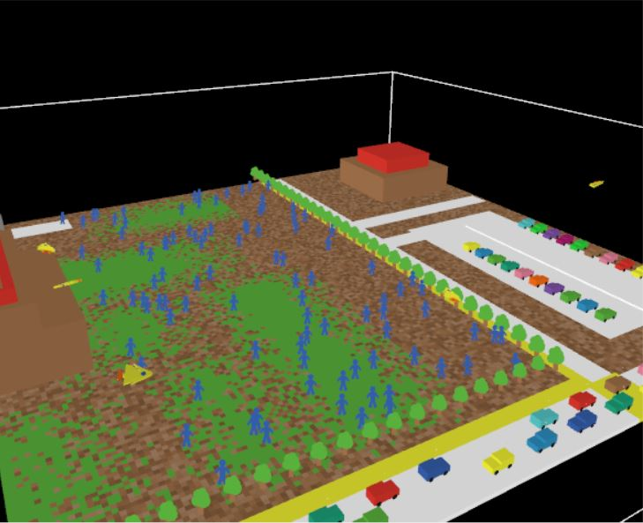

Fig 3: Surveillance of campus area

**3.3 MANUAL CONTROL**

The drones can be controlled through the keyword. In real world, the drones can also be controlled by the remote controller by an operator who is far away from the drone.

In this project, any specific drone or all the drones can be controlled through keyboard and can make the drone go to the specific location to keep an eye on that particular area.

In Fig 4, the manual controls to control the drone have been displayed. In Fig 5, the selection of a particular drone or all the drones has been demonstrated.

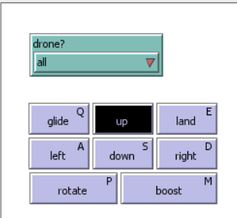 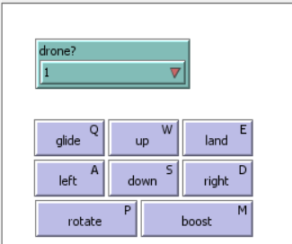

Fig 4: Manual controls

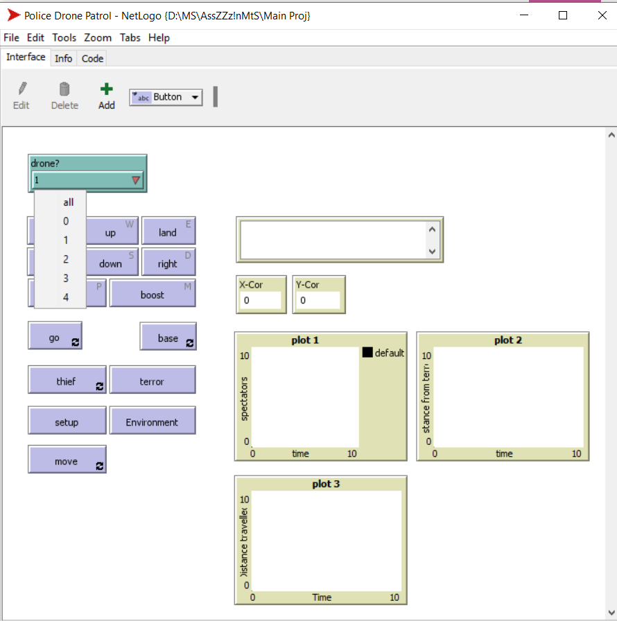

Fig 5: Selection of drone

**3.4 IDENTIFICATION OF HARMFUL SITUATIONS**

**SCENARIO 1:**

In Fig 6, the drones identify the unexpected fire break out in the campus and immediately arrive at the situation and send the location coordinates to the base.

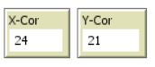

* These are the local coordinates of the fire break out sent by the drones.

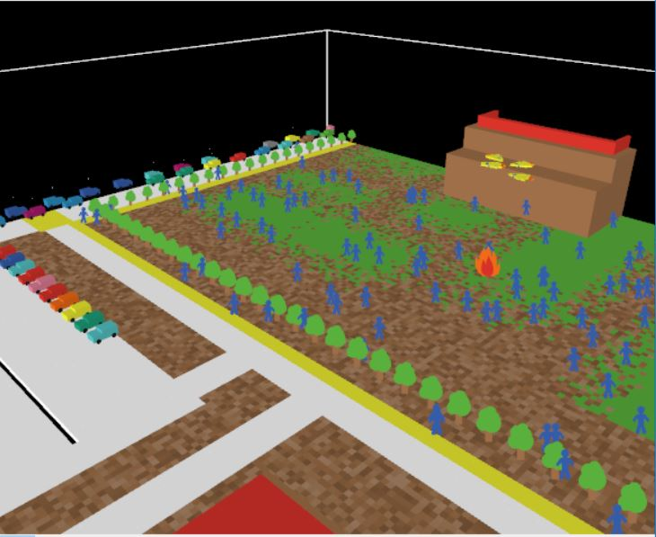

Fig 6: Arriving at the fire break out

**SCENARIO 2:**

In Fig 7, the drones identify the burglar or robber and follow him while and send the location coordinates to the base and keep them up to date.

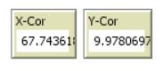

* These are the local coordinates of the burglar sent by the drones and these coordinates are updated as the drones follow the burglar.

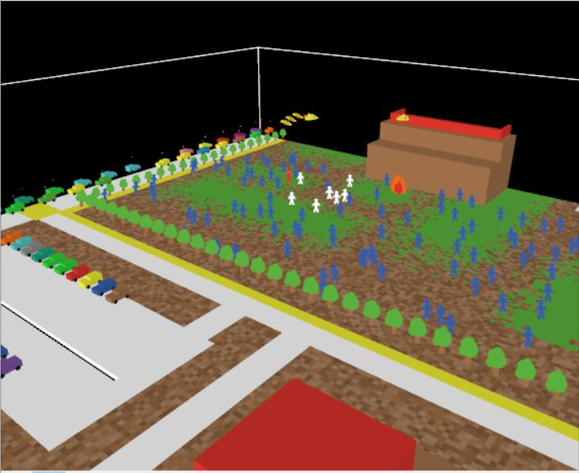

Fig 7: Aerial vehicles tracking down the burglar

**3.5 GRAPHS**

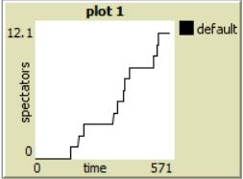

1. The X-axis is time and the Y-axis is the spectators.
2. This graph shows the number of people who have witnessed the burglar on campus.

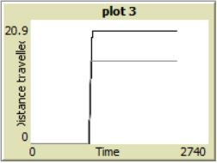

1. The X-axis is time and the Y-axis is the distance travelled by a particular drone.
2. This graph shows two lines where one line depicts the distance travelled by a particular drone to reach the firebreak and the other line shows the distance travelled by a particular drone to reach or get close to the burglar.

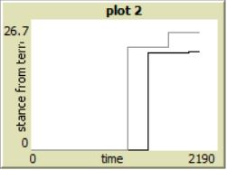

1. The X-axis is time and the Y-axis is the distance away from the situation.
2. This graph shows two lines where one line depicts the distance away by a particular drone from the firebreak and the other line shows the distance away by a particular drone from the burglar.

**4. IMPLEMENTATION**

**4.1 CREATION OF DRONES**

The integral part of the project is creation of the drones. The code down below is used to create the drones and the shape of the drone is down below:

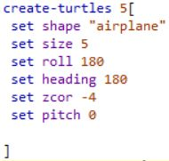 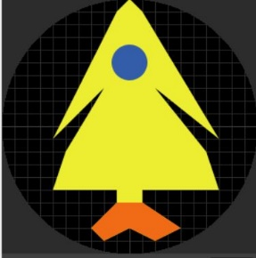

**4.2 MOVEMENT OF DRONES TO PURSUE**

The code down below is to move the drones in a certain path to reach the burglar and follow him

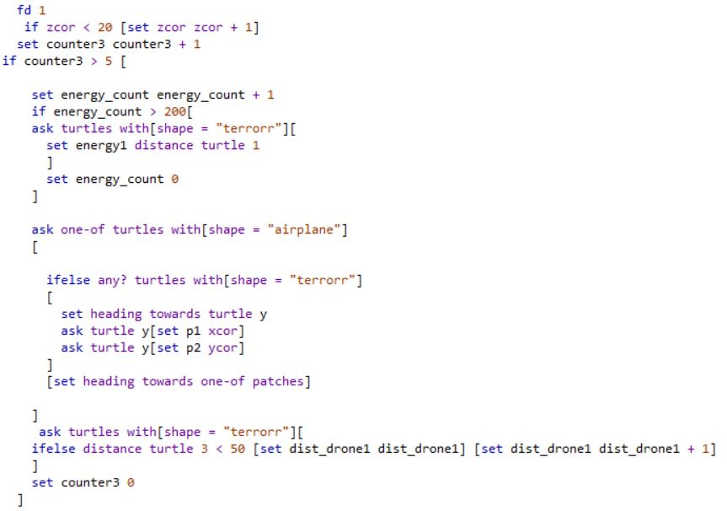

**4.3 HANDLING THE SITUATIONS**

The code is written to handle both the fire break out and the theft case at same time. One of the drones remain at the fire break out and the remaining drones deal with the theft case. In this way, both the situations are reported so that the police can able to deal with the situation in much better manner as they have prior knowledge about both the situations.

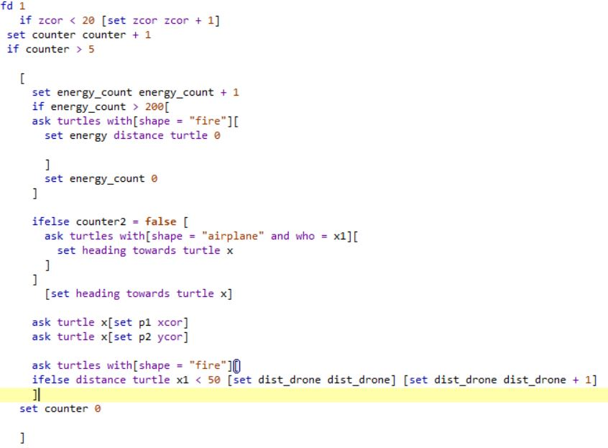

**5. TESTING AND EXECUTION RESULTS**

The execution of project is successful and the test results of the project are accurate. The below Fig 8, shows the output of the execution, depicts the graphs and display the local coordinates of scenario 1.

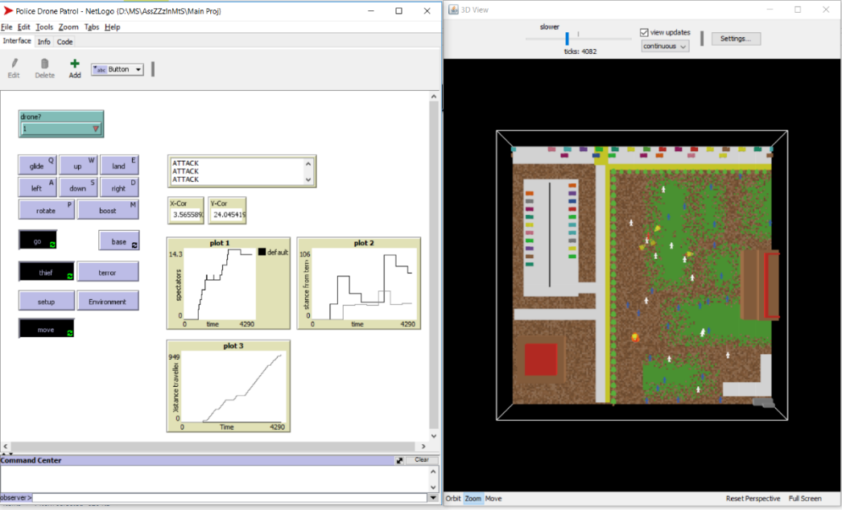

Fig 8: Final Execution of scenario 1

The below Fig 9, shows the output of the execution, depicts the graphs and display the local coordinates of scenario 2.

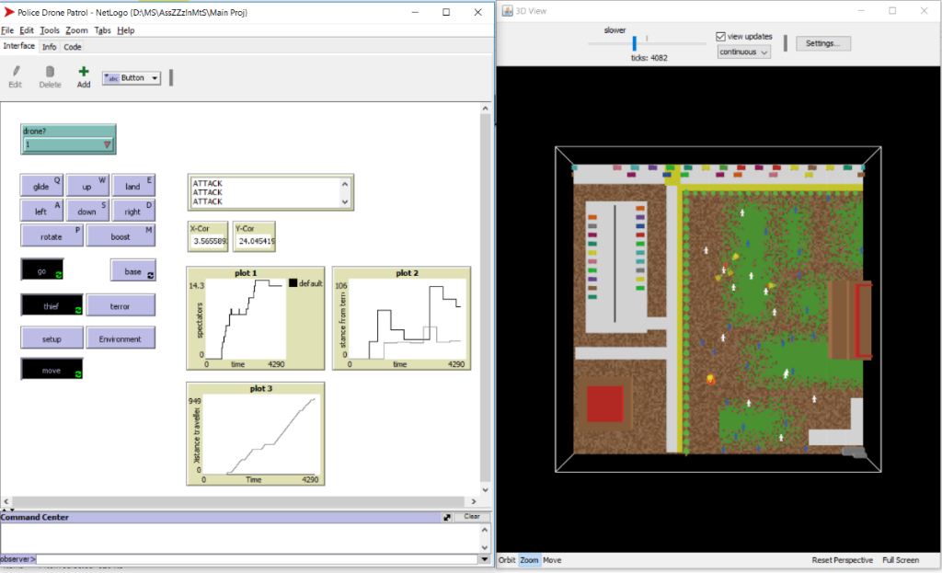

Fig 9: Final Execution of scenario 2

**6. CONCLUSION**

For the police, UAVs are required to perform work surveillance, reconnaissance, information gathering and tracking fixed and mobile targets, which are essential components in the performance of specific tasks aimed at protection of life and property.In this project, the drones work effectively to perform surveillance over the campus area and gather information such as location coordinates during difficult situations such as fire break out or a theft case and report that intelligence back to police. By usage of aerial vehicles, it enhances the safety of police officers to add useful manpower when responding to emergency situations, as a UAV could provide an aerial view and can able to maneuver comfortably anywhere.

**REFERENCES**

1. Research Report, Utah State University, Utah Water Research Laboratory, ‘Evaluation and Development of Unmanned Aircraft (UAV) for DOT needs,’ Report No. UT-12.08, July 2012.
2. Bennett, Brian. 2012. "Police departments wait for FAA clearance to fly drones,” Los Angeles Times, April 29. Accessed July 1, 2012. <http://articles.latimes.com/2012/apr/29/nation/la-na-drone-faa-20120430>.
3. Geiger, Harley. 2012. “Drone Countdown.” Center for Democracy and Technology, March 27. Accessed July 1, 2012. https://www.cdt.org/blogs/harley-geiger/2703drone-countdown (accessed July 1, 2012).
4. J. M. M. Neto, R. A. Da Paixao, L. R. L. Rodrigues, E. M. Moreira, J. C. J. Dos Santos, P. F. F. Rosa, "A surveillance task for a UAV in a natural disaster scenario", *Industrial Electronics (ISIE) 2012 IEEE International Symposium on*, pp. 1516-1522, 2012.
5. Florin Nedelcuţ, Current Aspects of Using Unmanned Aerial Vehicles in Environmental Monitoring, International Conference Management and Sustainable Protection of Environment, 6-7 mai 2009, Alba-Iulia.
6. Geiger, Harley. 2011. “The Drones are coming.” Center for Democracy and Technology, December 21.Accessed July 1, 2012. https://www.cdt.org/blogs/harley-geiger/2112drones-are-coming (accessed July 1, 2012).
7. Edward D. McCormack, ‘The Use of Small Unmanned Aircraft by Washington State Department of Transportation,’ Research Report Agreement T4118, Task 04, prepared for Washington State Transportation Commission, Department of Transportation, June 2008.
8. Koebler, Jason. 2012a. “First Man Arrested With Drone Evidence Vows to Fight Case.” U.S. News & World Report, April 9. Accessed August 4. http://www.usnews.com/news/articles/2012/04/09/first -man-arrested-with-drone-evidence-vows-to-fight-case.
9. Koebler , Jason. 2012b. “Court Upholds Domestic Drone Use in Arrest of American Citizen.” U.S. News & World Report, August 2. Accessed August 4. http://www.usnews.com/news/articles/2012/08/02/court-upholds-domestic-drone-use-in-arrest-of -american-citizen.